OUTCOMES

**Signup Form Without Entries 🡺**

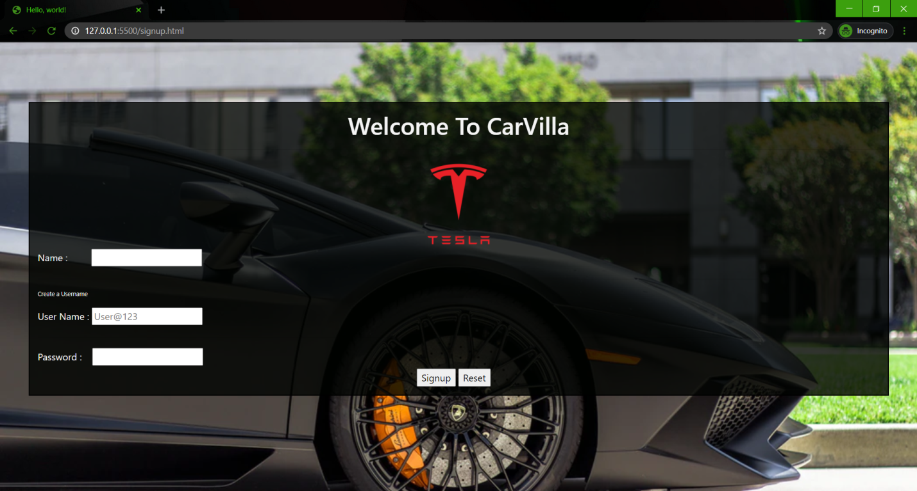

**Fillling The Signup Form 🡺**

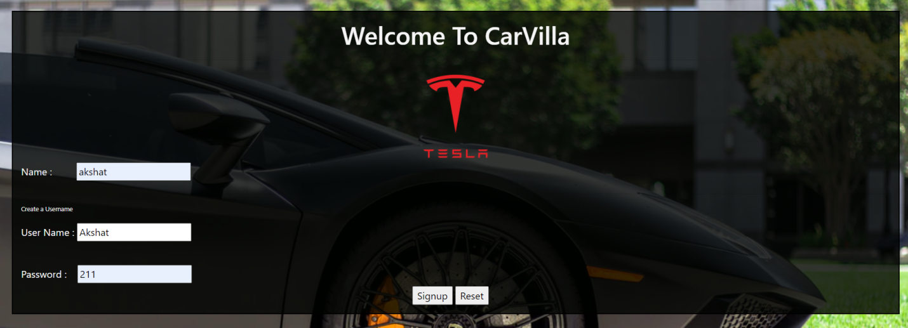

**Login Form 🡺**

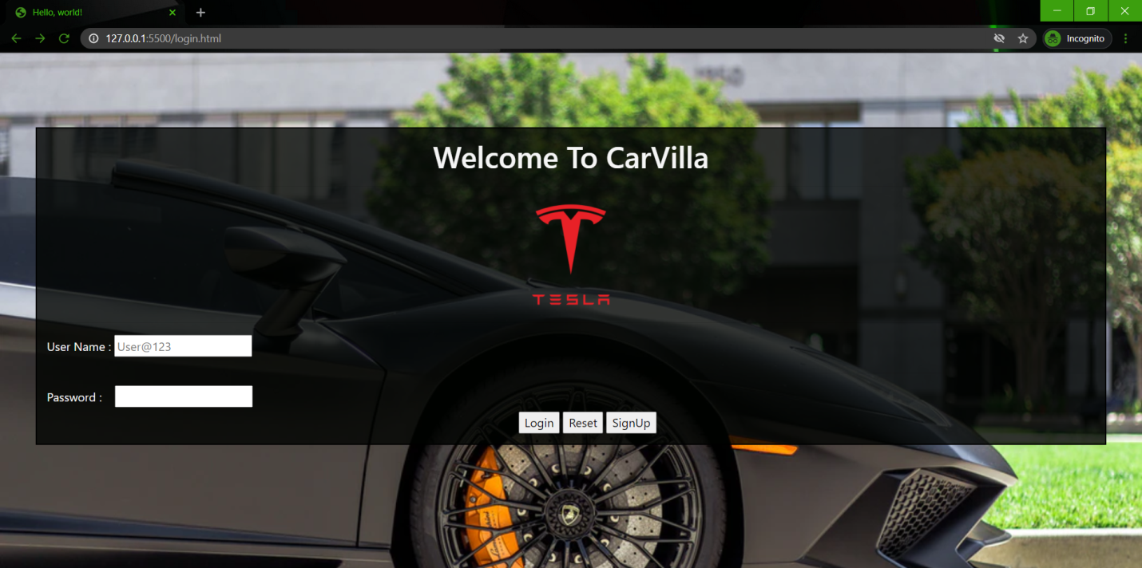

**Filling the Login Form 🡺**

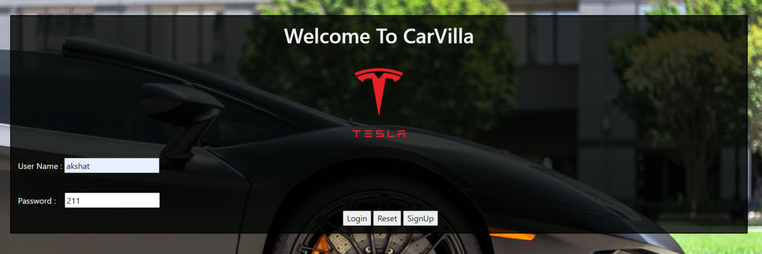

**User’s Data Will Get Inserted in the Backend 🡺**

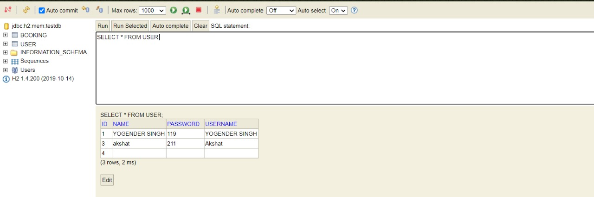

**After Login Successfully,Redirected To The Landing Page 🡺**

**Part 1 Of the Landing Page 🡺**

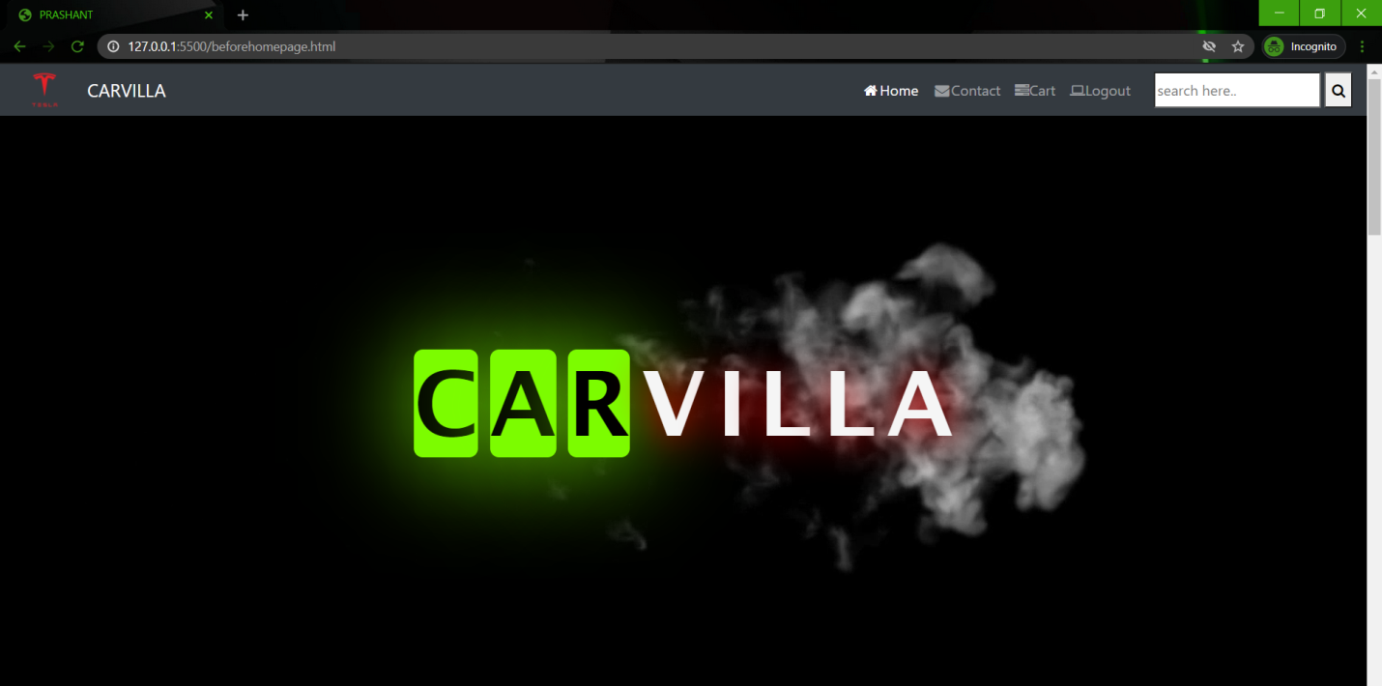

**Part 2 : Types Of Cars Available 🡺**

* **Normal cars**
* **Luxury Cars**

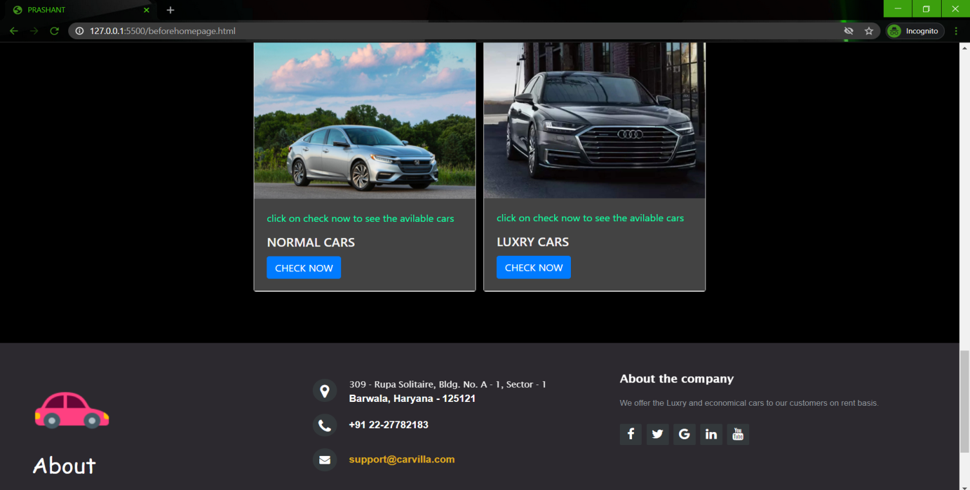

**After Clicking The Check Now Button, Redirected To the HomePage 🡺**

**User Name Will be Displayed Here**

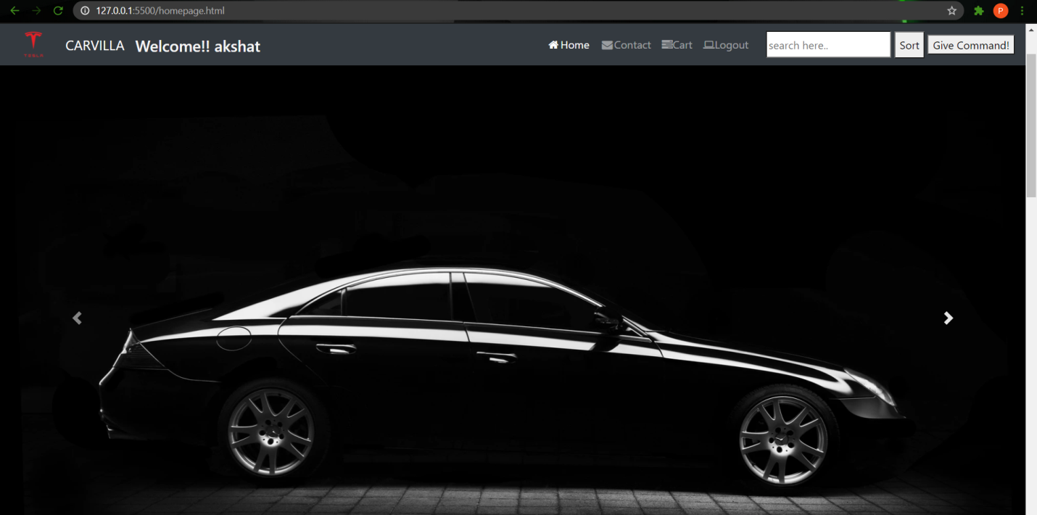

**Downwards HomePage 🡺 Displaying ,Cars Present in the Chosen Section**

* **Cars Are Randomly Placed on the screen , Not in a sorted Price manner**

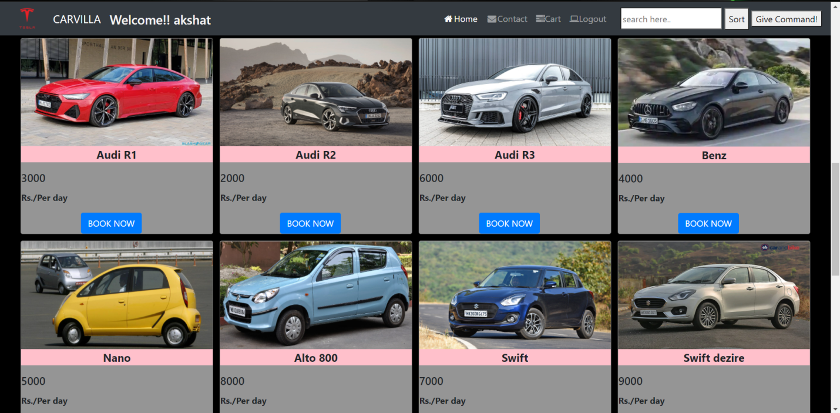

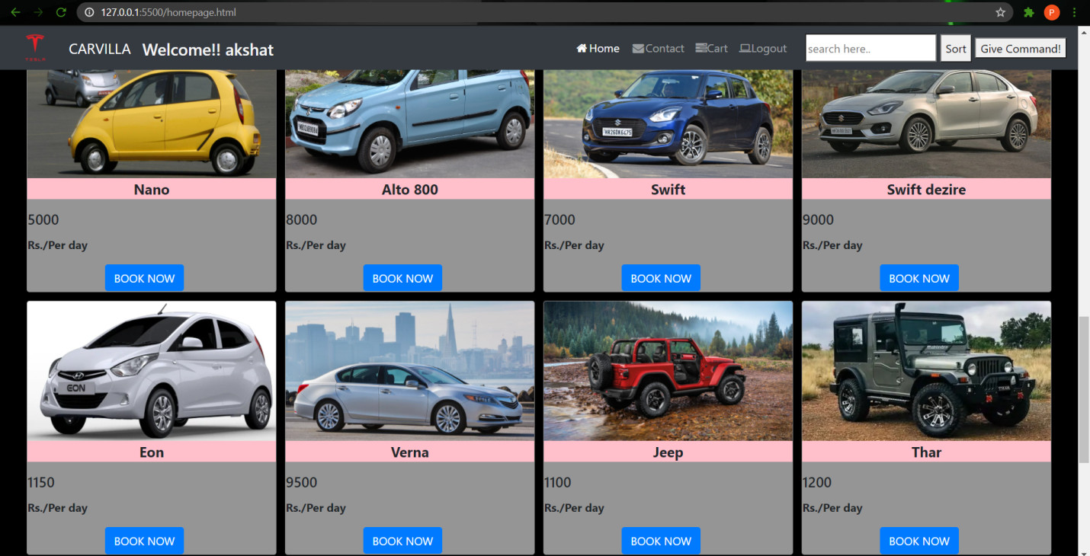

**After Clicking The Sort Button Present There 🡺 All The cars get sort and displayed in low to high Price manner**

**Sort Button**

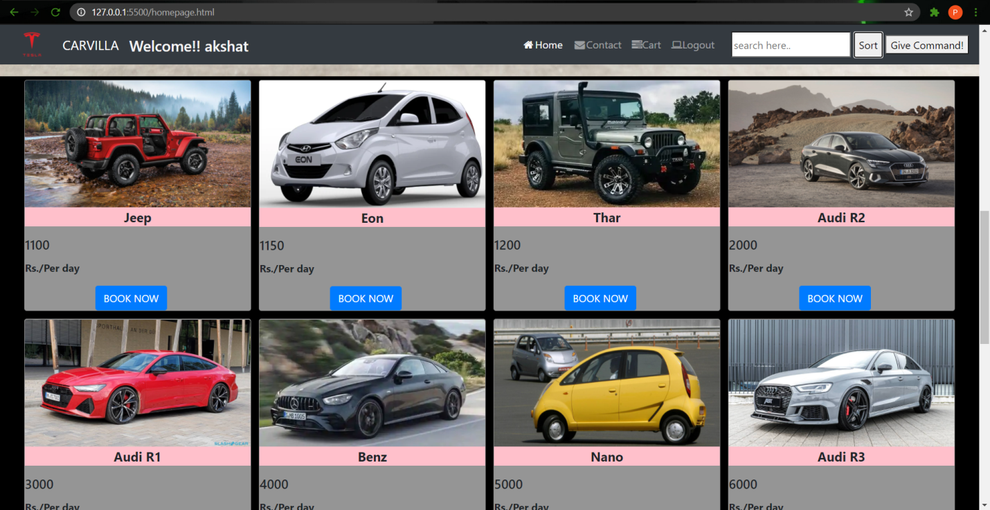

**User can use the search bar to find the car by its name just by typing the name of car or some relevant word in the search bar 🡺**

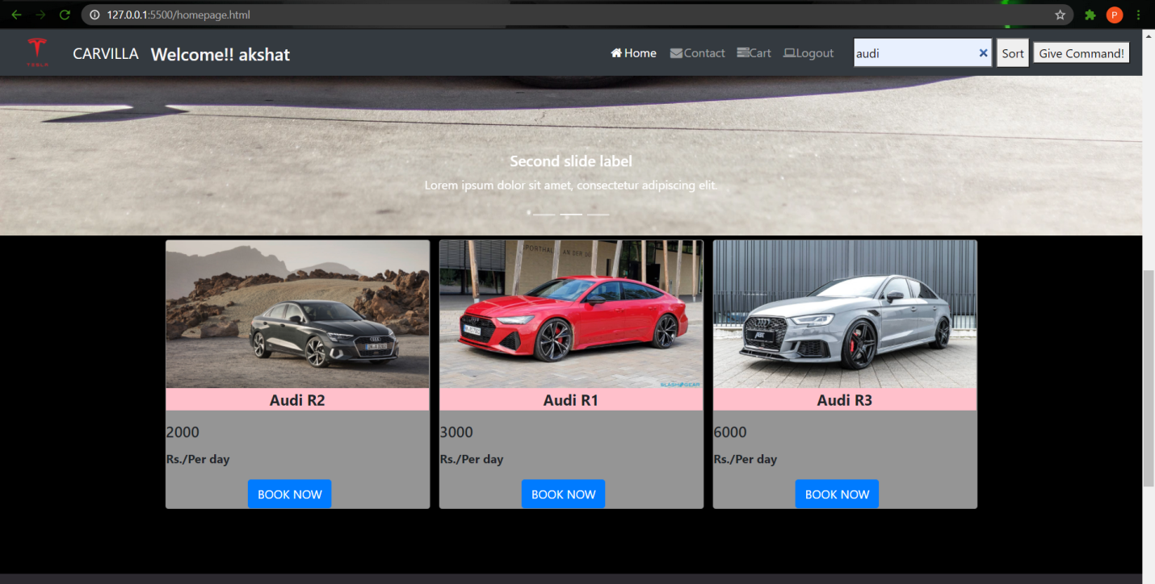

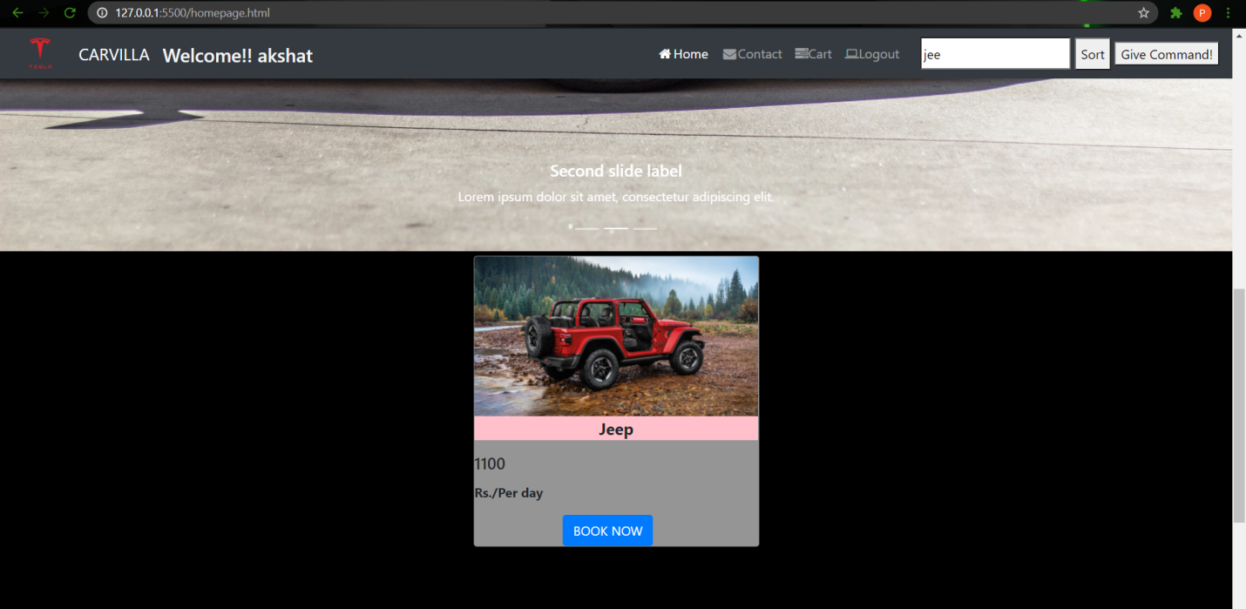

**We have Provided a “Give Command” Button , User can just give a voice command and search any car by just saying its name and sort the cars by just giving a command “Sort cars”**

* **Asking For the Microphone Permission**

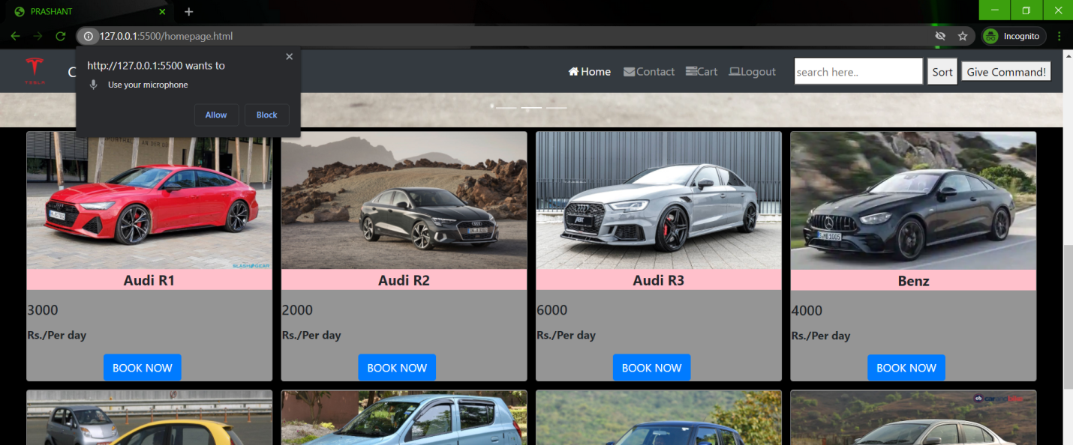

**It is showing That The Microphone Is 🡺“ON”**

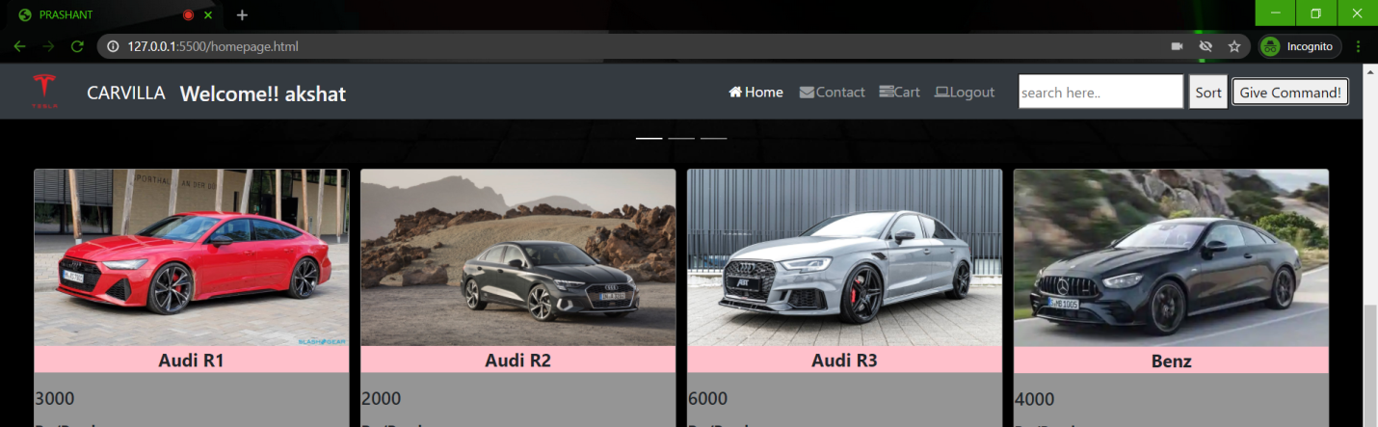

**User can Contact us in any difficult situation or for any Query 🡺**

* **Contact Form with vacant fields**

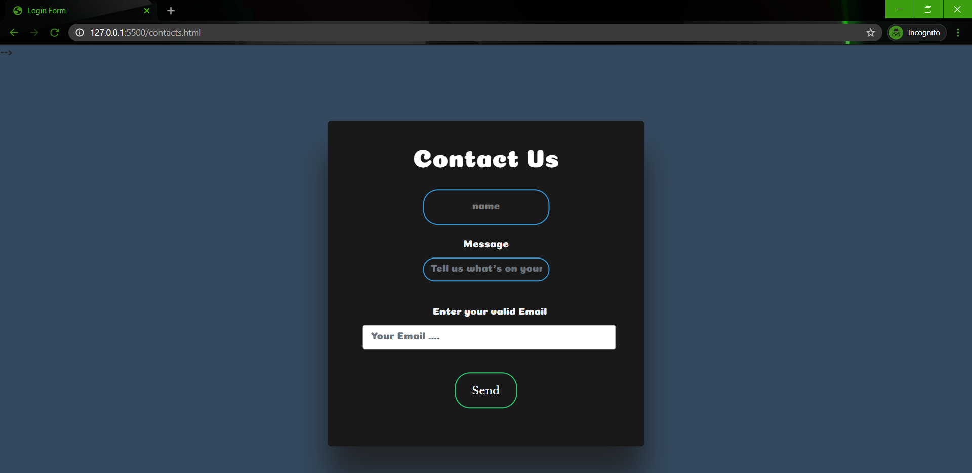

**Filling The Contact Form And Submitting It 🡺**

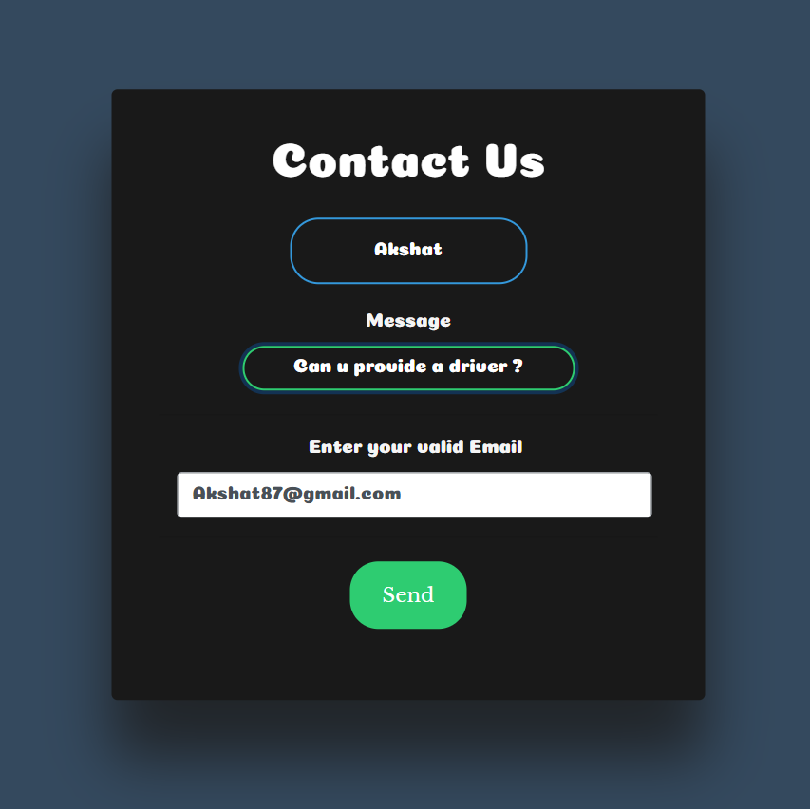

**We immediately got a mail from the user’s side 🡺**

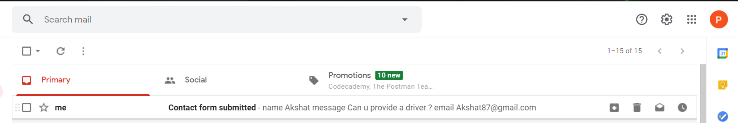

* **We can Respond to this mail anytime**

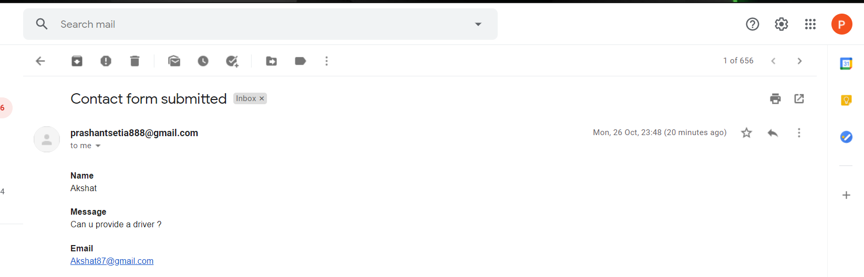

**Booking a Car from the car section By clicking ON “Book Now” Button 🡺**

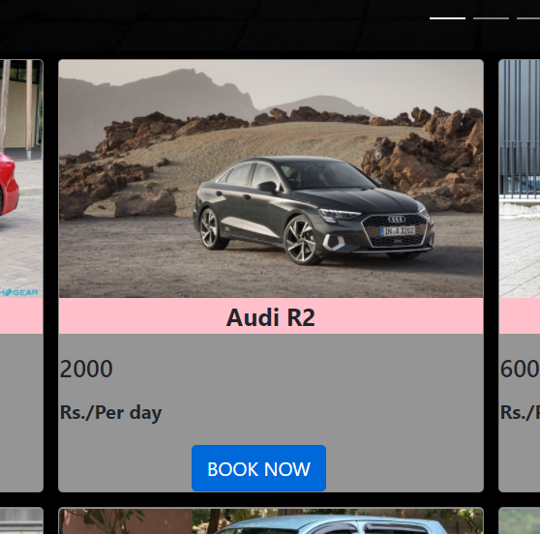

**Book Now Button**

**After Clicking the Book Now Button . Booking Form Will Open 🡺**

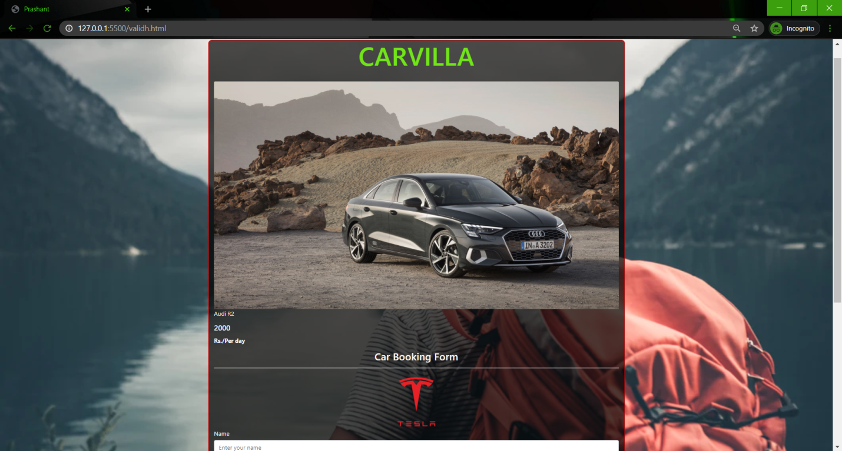

**This is a Validated Form. If we will Not fill it according to the instruction , It will give error and will show the Cross sign 🡺**

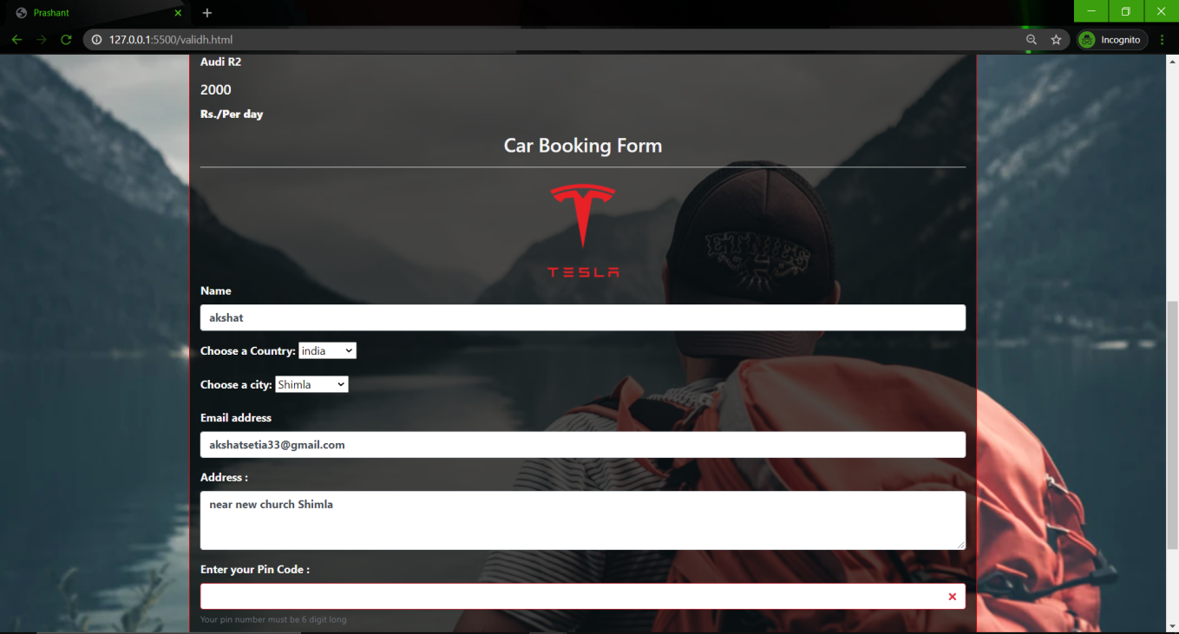

**Pin code field is not Filled That’s why showing the Cross sign here**

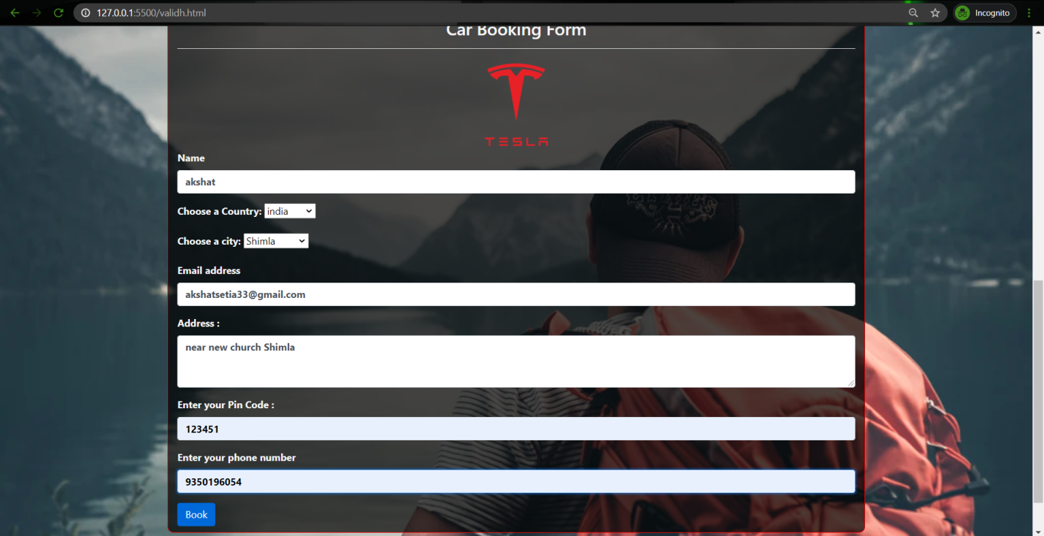

**After Clicking the “Book” Button. The Form Will Get Submit Successfully 🡺**

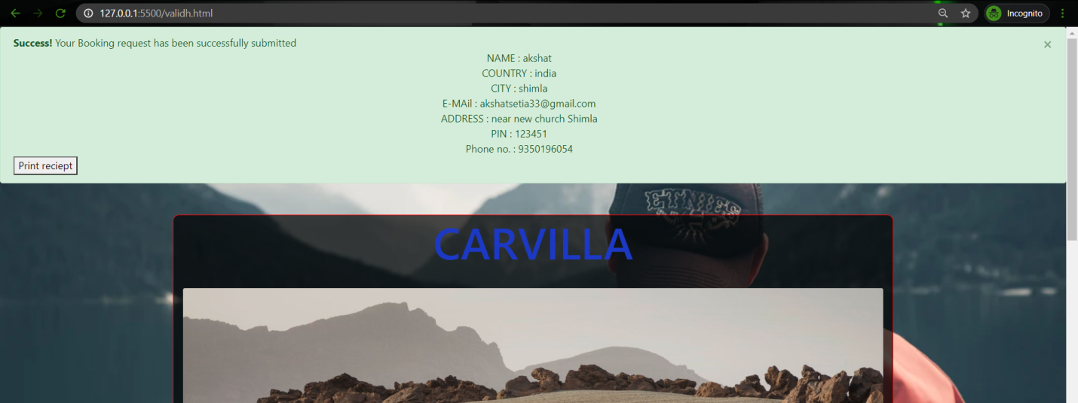

**Booking Form Data Will Get Inserted in the in the Backend 🡺**

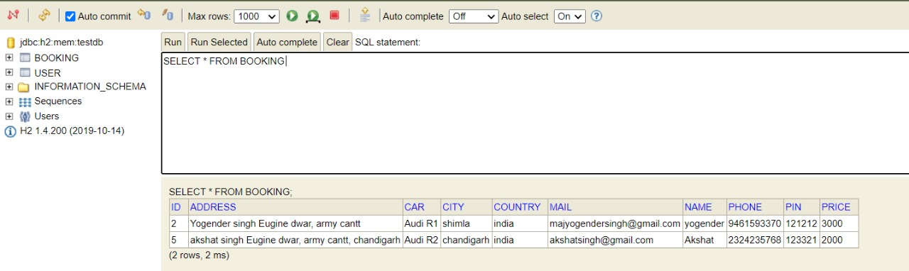

**Provided a “Print Button” To Print the Receipt**

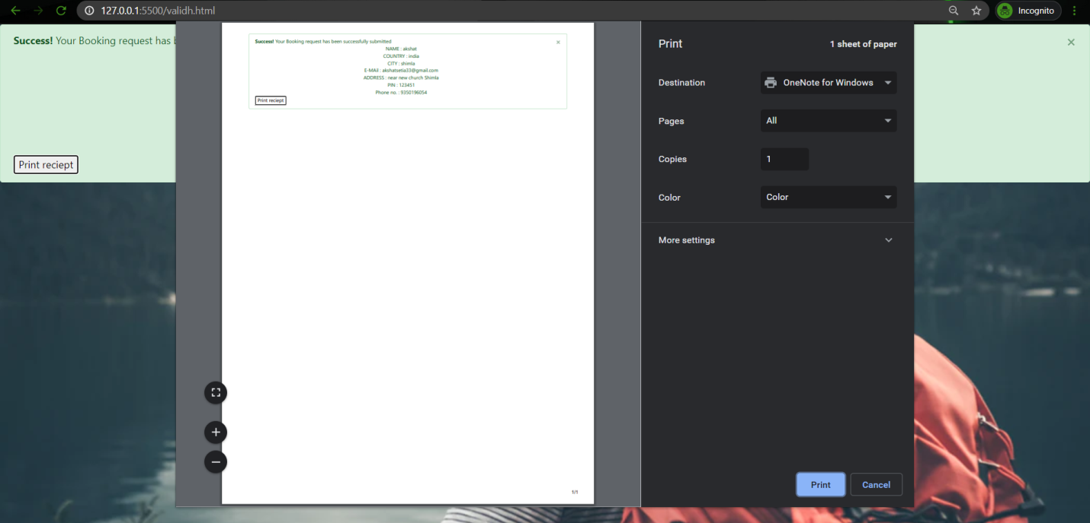

**Responsive Design**

